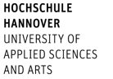

Faculty V
Diaconic Studies, Health Care & Social Work

No | Course | Lecturer | ECTS
Social Work
1. | 2.3. Becoming a social worker – global journeys into social work | Thomasi, Beatrix | 3,0
2. | M 12.2 Potential of Gardening for Social Work  projectreflexion group 4 | Thomasi, Beatrix | 3,0
3. | M 6.6 Community and sustainability Social Work in practice | Thomasi, Beatrix | 3,0
6. | M7.3 Eco Activism and Social Work – new directions in Leadership and Group Work | Thomasi, Beatrix | 3,0
7. | M 10.6 Ethics of recognition in their relevance for committed community work. To become aware of the others and yourself | Loos, Christian | 3,0
8. | M5.1 Identity: What is it and why does it matter to social work?" | Von Denkowski, Cordula | 3,0
9. | 10.2. BIP Suicide Prevention, 10.-16.03.2024, Excursion Portugal | Plobner, Annette | 3,0
10. | 10.3. Group Leading Intensive  Online Friday 9-13Uhr: 5.4./12.4./19.4./26.4./3.5./17.5.2024 | Craig Whisker | 3,0
11. | M 3.1 Linking Social Work and Sustainable Development – Theories and Concepts | Marianna Krause | 3,0
 | Language and Interdisciplinary Courses
12. | Orientation week with an integrated intensive German course | International Office + Language Center | 3
13. | Further language courses (German 6 ECTS/English 3 ECTS) | Language Center | 6/3
14. | English Communication skills and or Presentation Techniques | Ben Trutz | 3/3
15. | Next Material ( sustainable aspects of materials) | Faculty of Media & Design | 3
16. | Design Thinking tbc | Faculty of Media & Design | 3
17. | Social media What`s next? tbc | Faculty of Media & Design | 3

Social Work: International Program
Summer Term 2024

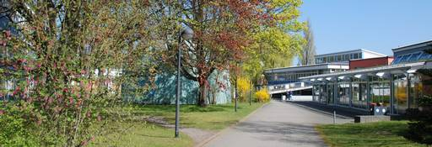

Contact
Hochschule Hannover
Faculty V – Diaconic Studies, Health Care and Social Work
Blumhardtstraße 2
30625 Hannover, Germany

International Coordinator
Annette Plobner
Tel.: +49 511 9296-3190
E-mail: annette.plobner@hs-hannover.de

International Faculty Office
N.N.

