

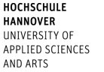

Faculty V
Diaconic Studies, Health Care & Social Work

No | Course | Lecturer | ECTS
Social Work
1. | „Becoming a social worker – global journeys into social work“, 25./26. Okt. and 15./16. Nov. 2024 | Thomasi, Beatrix | 3,0
2. | M 10.5 „Project Management for international socialworker“  8./9.10. Jan. 2025 9 – 17 | Thomasi, Beatrix | 3,0
3. | M 6.6 and M 3.2 „Working in communities in times of disaster“, thursday 14 – 16 | Thomasi, Beatrix | 3,0
4. | M 12.2 „Potential of Gardening for social work“  projectreflecion group 4 Thursday 11-13 | Thomasi, Beatrix | 5,0
5. | 6.6 and 3.2 „Responsibility and Cooperation in Times of Uncertainty. (Green) Social Work issues for a demarginalizing futures“ 18./19./20. Nov. 2024, 9 – 17 | Loos, Christian | 3,0
6. | M 9.2 „Psychosocial Risks in the Work Environment“ BIP in Ljubljana 2.-7.Febr. 2025 | Von Denkowski, Cordula | 3,0
7. | M 5.1 “Social Neuroscience”, Wednesday, 14 – 16 | Schiffhauer, Birte | 3,0
8. | 14.5 Lecture series “Peacebuilding – Challenges for social work and education”, Thursday 17.00 – 18.30 Online | Von Denkowski, Cordula and  Various professors | 3,0
9. | 5.2 "Mental health: living with psychological disorders"  - Online preliminary meeting in the first week of Oct. 25.10.2024 13:30 - 17:00 and 26.10.2024 09:00 – 17:00 / 15.11.2024 13:30 - 17:00 and 16.11.2024 09:00 – 17:00 | Baller, Frauke | 3,0
Language and interdisciplinary courses
11. | Presentation techniques or  Communication skills | Trutz, Ben | 3,0
12. | Orientation week with an integrated intensive German course | International Office + Language Center | 3,0
13. | Further language courses (German 6 ECTS/English 3 ECTS) | Language Center | 6/3

Social Work: International Program
Winter Term 2024/25

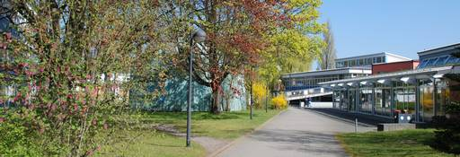

Contact
Hochschule Hannover
Faculty V – Diaconic Studies, Health Care and Social Work
Blumhardtstraße 2
30625 Hannover, Germany

International Coordinator
Annette Plobner until July 31, 2024
E-mail: annette.plobner@hs-hannover.de
Prof. Dr. Cordula von Denkowski from August 1st, 2024
E-mail: cordula-von.denkowski@hs-hannover.de

International Faculty Office
N.N.

