ERASMUS+ Strategic partnership 2016-2019, A comparative view on the well-treatment of people in European’s specialized institutions [Orig.: Regards croisés européens sur la bientraitance des personnes en institut spécialisé. Institut Régional du Travail Social de ChampagneArdenne].
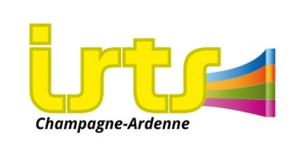
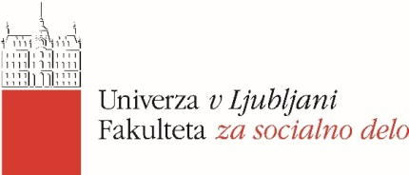

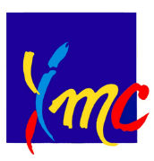
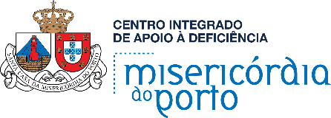

International Conference, University of Ljubljana, Faculty of Social Work
Thursday, 12. April 2018, 9:30-17.30

Overcoming Institutional Routine in long-term welfare services for persons with disabilities
/Prevod: Ravnanje z institucionalno rutino v institucijah za dolgotrajno bivanje ljudi z ovirami, četrtek 12. Aprila 2018, 9.30-17.30 ure/

Start | End | CONTENT OF THE PROGRAMME
09.30 | 09.50 | Welcome of the Erasmus+ partners and the conference participants  Vesna Leskošek, Dean of the Faculty of Social Work  Darja Zaviršek, Faculty of Social Work and Erasmus+
09.50 | 10.20 | Dealing with the institutional routine, according to professionals, users and students  Nicolas Perrein, Michèle Latu and the French team  Q/A
10.20 | 10.50 | Institutional routine as an institutional problem and how to overcome it in Slovenia?  Valerija Bužan, director of Training, Education and Care Centre "Dolfke Boštjančič", Draga and vice president of the EASPD  Q/A
10.50 | 11.20 | COFFEE BREAK
11.20 | 11.50 | From the absence of the concept to the development of a well-treatment awareness  João Belchior, Berta Granja and the Portuguese team  Q/A
11.50 | 12.20 | Research on the experiences of the institutional routine in the Community Organisation Altra  Suzana Oreški, Andraž Kapus and Tilen Recko  Q/A
12.20 | 13.00 | International Voices: what is good treatment from the perspective of service users in Ireland, Spain and Slovenia (Film 25 minutes, IASSW)
13.00 | 14.00 | LUNCH BREAK
14.00 | 15.00 | Parallel workshops  - Workshop I: Institutional routine from the perspective of the service users : international perspective  - Workshop II: Institutional routine from the perspective of the professional workers : international perspective  - Workshop III: Institutional routine from the perspective of the students : international perspective  - Workshop IV: Institutional routine from the perspective of the educators: international perspective
15.00 | 15.20 | COFFEE BREAK
15.20 | 16.20 | Reports from workshops  Facilitator: Gašper Krstulović  How do students, service users, professional workers and educators see the issue of overcoming institutional routine: countries' comparison
16:20 | 17:20 | Film: YHD – Young, Bold, Beautiful (a film made by a disability organisation about their work on the project of personal assistance) 30 minutes  Facilitator: Emanuela Fabijan  After the film a discussion with the disabled authors of the film and the leaders of the YHD organisation will take place  Invited guests:  Elena Pečarič, President of the YHD  Klaudija Poropat, Programme manager of the Center for Independent living  Katrin Modic, librarian, disability awareness worker  Emil Bohinc, coordinator of the CIL
18.00 | 20.00 | Dinner at the Faculty of Social work with Slovenian wines

